Tree Grafting
Time Limit: 5000MS |  | Memory Limit: 65536K
Total Submissions: 1806 |  | Accepted: 778
Description
Trees have many applications in computer science. Perhaps the most commonly used trees are rooted binary trees, but there are other types of rooted trees that may be useful as well. One example is ordered trees, in which the subtrees for any given node are ordered. The number of children of each node is variable, and there is no limit on the number. Formally, an ordered tree consists of a finite set of nodes T such that
- there is one node designated as the root, denoted root(T);
- the remaining nodes are partitioned into subsets T1, T2, ..., Tm, each of which is also a tree (subtrees).
Also, define root(T1), ..., root(Tm) to be the children of root(T), with root(Ti) being the i-th child. The nodes root(T1), ..., root(Tm) are siblings.
It is often more convenient to represent an ordered tree as a rooted binary tree, so that each node can be stored in the same amount of memory. The conversion is performed by the following steps:
- remove all edges from each node to its children;
- for each node, add an edge to its first child in T (if any) as the left child;
- for each node, add an edge to its next sibling in T (if any) as the right child.
This is illustrated by the following:
0 0
/ | \ /
1 2 3 ===> 1
/ \ \
4 5 2
/ \
4 3
\
5
In most cases, the height of the tree (the number of edges in the longest root-to-leaf path) increases after the conversion. This is undesirable because the complexity of many algorithms on trees depends on its height.
You are asked to write a program that computes the height of the tree before and after the conversion.
Input
The input is given by a number of lines giving the directions taken in a depth-first traversal of the trees. There is one line for each tree. For example, the tree above would give dudduduudu, meaning 0 down to 1, 1 up to 0, 0 down to 2, etc. The input is terminated by a line whose first character is #. You may assume that each tree has at least 2 and no more than 10000 nodes.
Output
For each tree, print the heights of the tree before and after the conversion specified above. Use the format:
Tree t: h1 => h2
where t is the case number (starting from 1), h1 is the height of the tree before the conversion, and h2 is the height of the tree after the conversion.
Sample Input
dudduduudu
ddddduuuuu
dddduduuuu
dddduuduuu
#
Sample Output
Tree 1: 2 => 4
Tree 2: 5 => 5
Tree 3: 4 => 5
Tree 4: 4 => 4
Source
#include <iostream>
#include <string>
using namespace std;
string s;
int i,n=0,height1,height2;int num=0;
void work(int level1,int level2)
{
int tempson=0;
while (s[i]=='d')
{
i++; tempson++;
work(level1+1,level2+tempson);
}
height1=level1>height1?level1:height1;
height2=level2>height2?level2:height2;
i++;
}
int main()
{
while (cin>>s && s!="#")
{
i=height1=height2=0;
work(0,0);
cout<<"Tree "<<++n<<": "<<height1<<" => "<<height2<<endl;
}
return 0;
}

就是将一个节点的第一个儿子放在左儿子的位置,下一个的儿子,即左儿子的第一个兄弟,
放在左儿子的右儿子位置上,再下一个兄弟接着放在右儿子的右儿子.
由题目给出的字符串,可以轻松求出多叉树.但是题目问的是转为二叉树的高度......
由于多叉树转二叉树的方法是"左儿子右兄弟",因此 二叉树中X节点的高=二叉树中X的父节点的高+X是第几个儿子-1
多叉树中X节点的高=多叉树中X的父节点的高+1
形成了一个递归定义. 可以用递归算法解决.
此题有几个d是连续的说明他有几个子节点 通过这能计算出来 他是第几个儿子
#include <iostream>
#include <string>
using namespace std;
string s;
int i,n=0,height1,height2;int num=0;
void work(int level1,int level2)
{
int tempson=0;
cout<<"mark1 use"<<i<<endl;
while (s[i]=='d')
{
i++; tempson++;
cout<<"1 i="<<i<<endl;
work(level1+1,level2+tempson);
cout<<"2 i="<<i<<endl;
}
height1=level1>height1?level1:height1;
height2=level2>height2?level2:height2;
i++;
cout<<"mark2 return"<<i<<" height1="<<height1<<endl;
}
int main()
{
while (cin>>s && s!="#")
{
i=height1=height2=0;
work(0,0);
cout<<"Tree "<<++n<<": "<<height1<<" => "<<height2<<endl;
}
return 0;
}

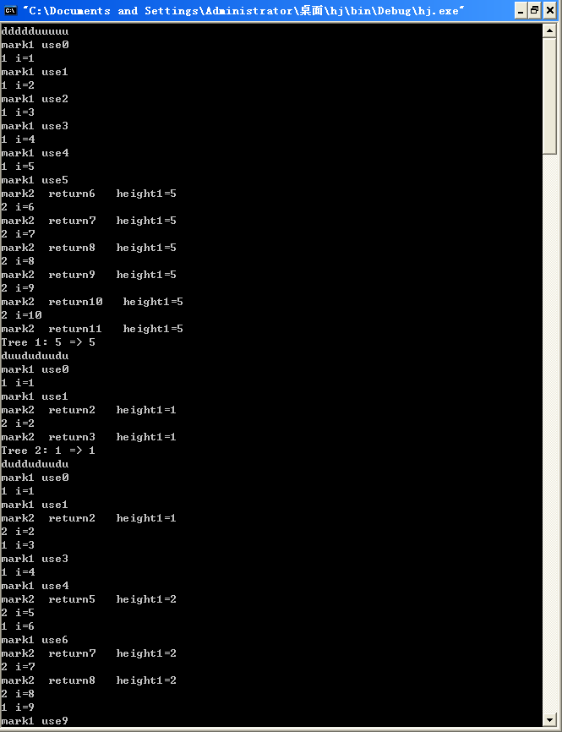

我终于想明白了 怎么这么的巧妙 其实想明白了就没什么了 可是真的很难想到啊 到现在还有一点晕 它是利用了全局变量 I 来控制下一个数 还有那个回溯
一对du 正好结束一个回溯 回到上一个平台 想不到啊 递归真的很巧妙
我要再好好领悟领悟
关于递归
复杂点说 就是个V型 针对这道题来说 如下图 一个圈内便是一个递归循环的结束 个人感觉递归用处广 有很灵活 用的方法有很多 如DFS 或是斐波那契数列 等等 有待好好总结 值得注意的还有本体递归的递归出口问题 巧就巧在他一定是对称的 所以一定会结束 而且正好 其实所有的递归都可转换成这种模型 这只是最基础最直观的 遍历对于树来说非常常见 例如tarjan算法 巧妙的利用了 递归的顺序！！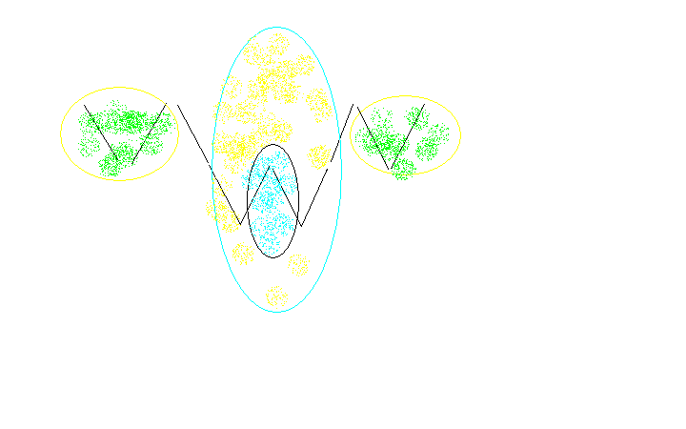

#include <iostream>
using namespace std;
char str[10001];int p;int tempson;int height1,height2;
void DFS(int level1,int level2)
{
p++; cout<<"use "<<endl;
if(str[p]=='d')
{
tempson++; //cout<<"level2="<<level2<<endl;
DFS(level1+1,level2+tempson);
cout<<"p="<<p<<endl;
if(str[p]!='\n') DFS(level1,level2);
}
else
{//cout<<"height2="<<height2<<endl;
cout<<"sad "<<endl;
tempson=0;
height1=height1>level1?height1:level1;
height2=height2>level2?height2:level2;

}
}
int main()
{
int T=0;
while(cin>>str)
{
if(str[0]=='#') break;
height1=0;height2=0;p=-1;tempson=0;
DFS(0,0);
cout<<"Tree "<<++T<<": "<<height1<<" => "<<height2<<endl;
}
return 0;
}

难道非用循环不可吗？？我还没理解深刻 也许我明白 但好像不用循环就是不行

